**Lab 9 Activity 2 - Calculating Total Marks and Percentage**

**Objective -** Use formulas to calculate total marks and percentage automatically.

1. In the Total column, use =SUM(C2:G2) (assuming C2:G2 contains subject marks).

2. In the Percentage column, use =(H2/200)*100 (assuming H2 contains the total marks out of 200).

3. Use the fill handle to apply formulas to other rows.

4. Format percentage values to show up to two decimal places.

5. Save the file.

**_________________________ ___________________________________________________________**

**Solutions:**

**Task 1:**

• Click on **Cell H2** (under the "Total" column).

• Enter the formula: “=SUM(C2:G2)”

• Press **Enter**.

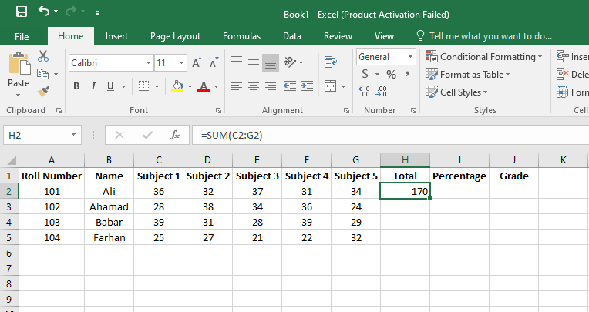

**Task 2:**

• Click on **Cell I2** (under the "Percentage" column).

• Enter the formula: “=(H2/200)*100”

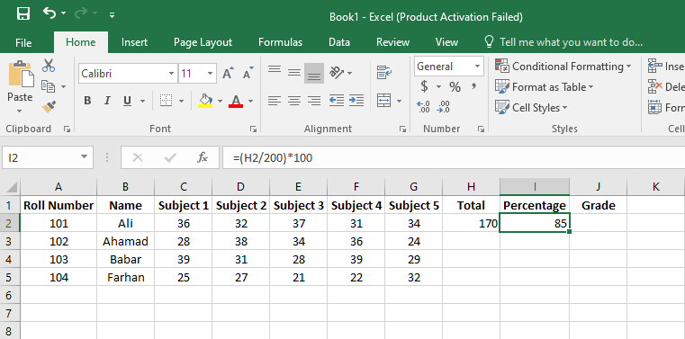• Press **Enter**

**Task 3:**

• Use the **fill handle** (a small square at the bottom-right of the cell) and **drag down** to apply the formula to other rows.

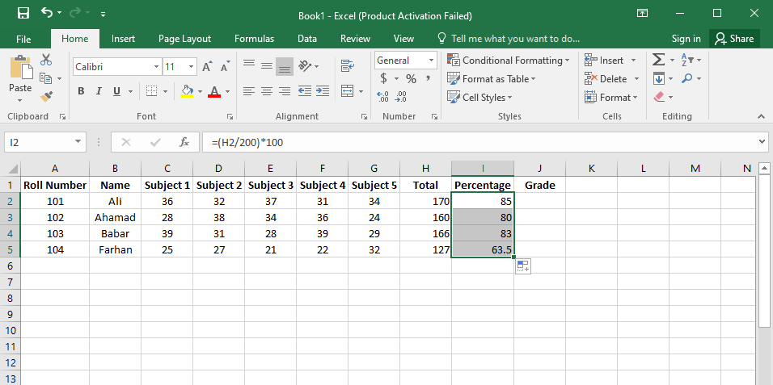

**Task 4:**

1. Select all percentage values (e.g., **I2 to I10**).
2. Click **Home > Number Format > More Number Formats**.
3. Select **Number**, set **Decimal places** to **2**, and click **OK**.

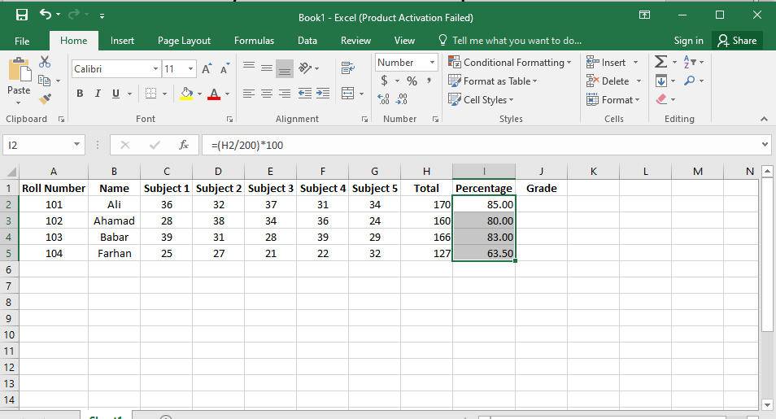

**Task 5:**

1. Click **File > Save As**.
2. Choose a location and select **Excel Workbook (.xlsx)** format.
3. Name the file **"Student_Marks.xlsx"** and click **Save**.